**Market Segment Analysis of EV Vehicles**

by

Prajapati Taksh Rajeshkumar

Dataset used:

https://drive.google.com/file/d/1yeTKNvAxCALz4QIKluGZqDFc6GbHt9dV/view?usp=sharing

Project link:

https://github.com/TakshPrajapati/Intern_Feynnlabs

1. Data Pre-Processing:

Data preprocessing is a crucial step in preparing raw data to make it suitable for machine learning models. The process involves cleaning the data, removing any errors or inconsistencies, and transforming it into a format that can be easily analyzed. It is essential to preprocess the data before performing any segmentation analysis.

To preprocess data, the first step is to import the raw data in a suitable format and create a data frame for further analysis. The next step is to identify any null values in the dataset and remove them to avoid any data inconsistencies.

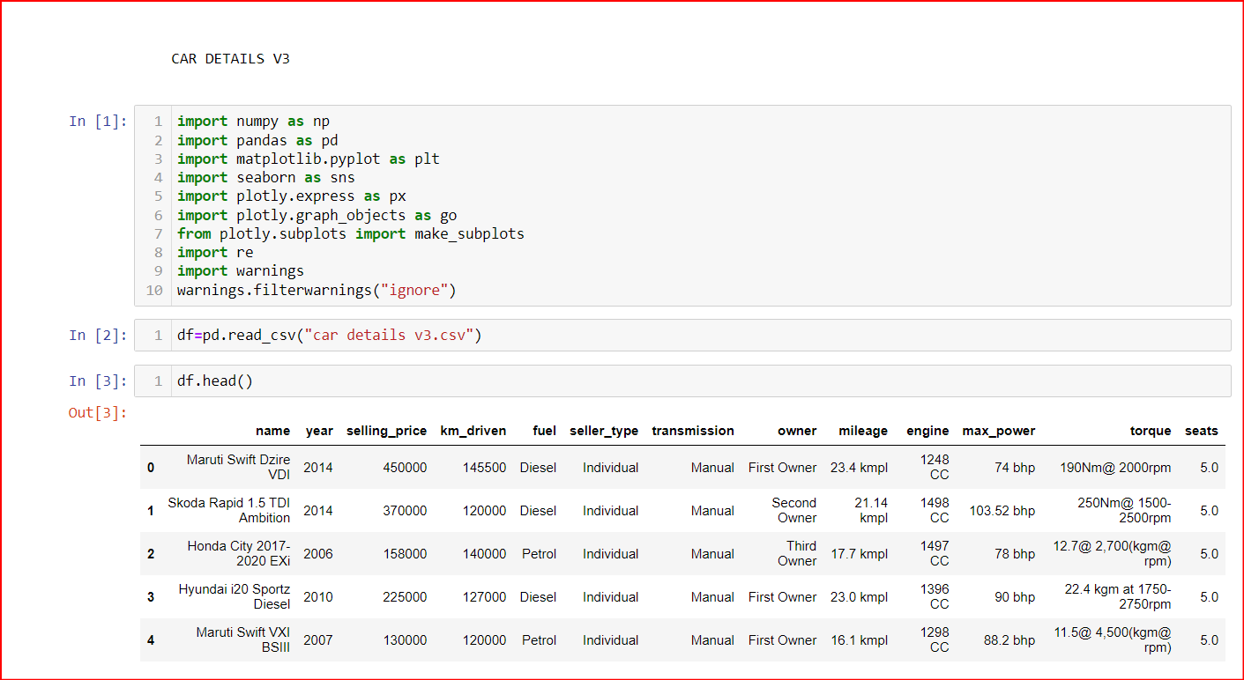

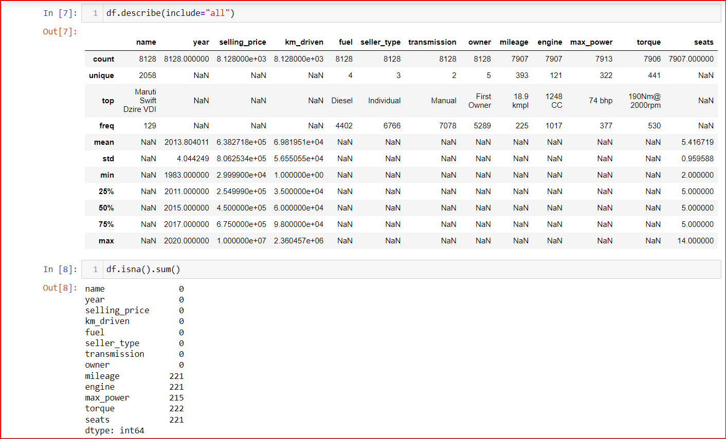

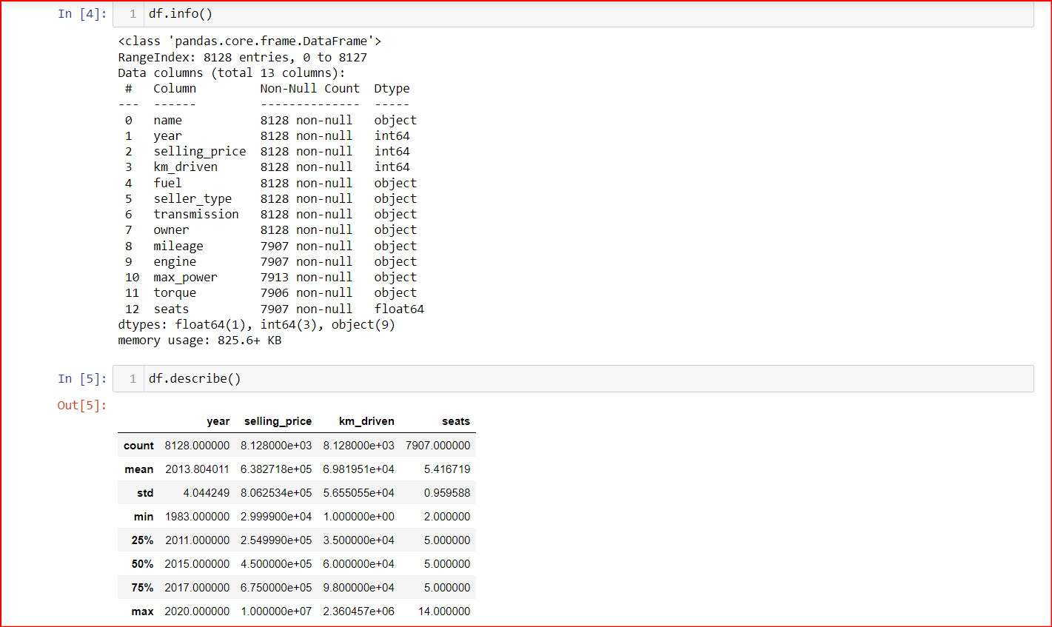

To make the attributes of data easier to understand we make changes to it known as Label encoding which is a technique used to represent categorical variables as numerical variables so that machine learning models can use them as inputs.

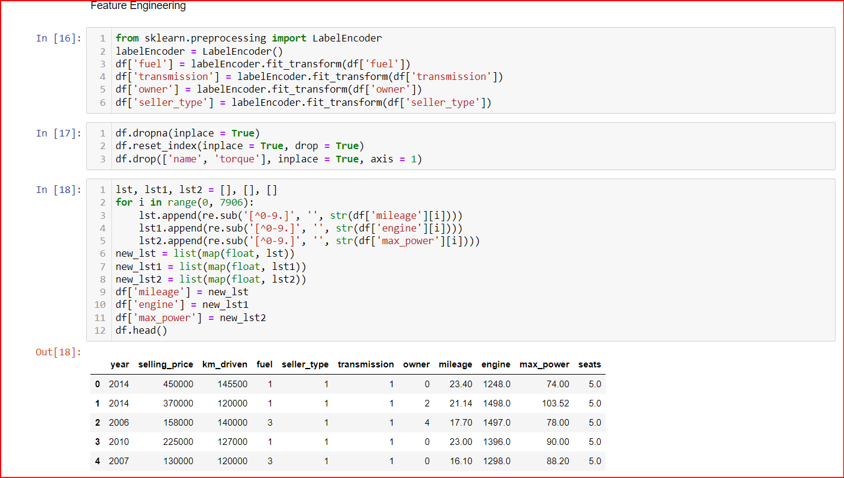

2. Visualization

Data visualization is used to make complex data easier to understand, identify relationships and correlations, and communicate insights and findings to others. It also makes data more engaging, which can encourage people to explore it further. Finally, data visualization supports decision-making by providing a clear, visual representation of the data that can help identify trends and patterns that might be missed in other forms of analysis.

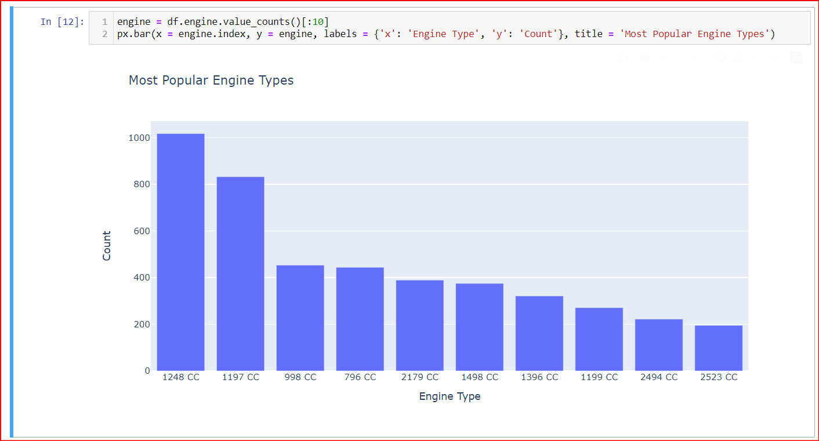

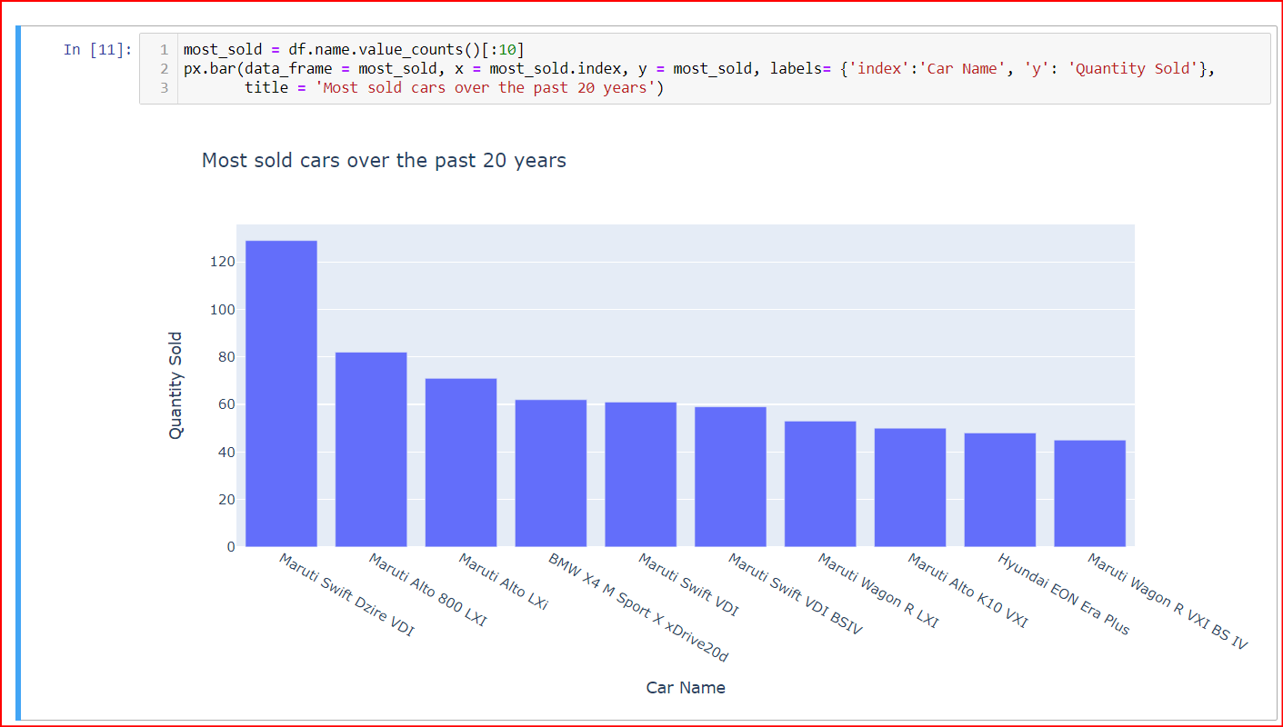

3. Geometric Analysis

Geometric analysis is used to study geometric objects and their properties such as shape, size, and position. It is used to provide a rigorous mathematical foundation for various areas such as physics, engineering, and computer science. Geometric analysis enables the development of powerful tools to solve complex problems in these fields.

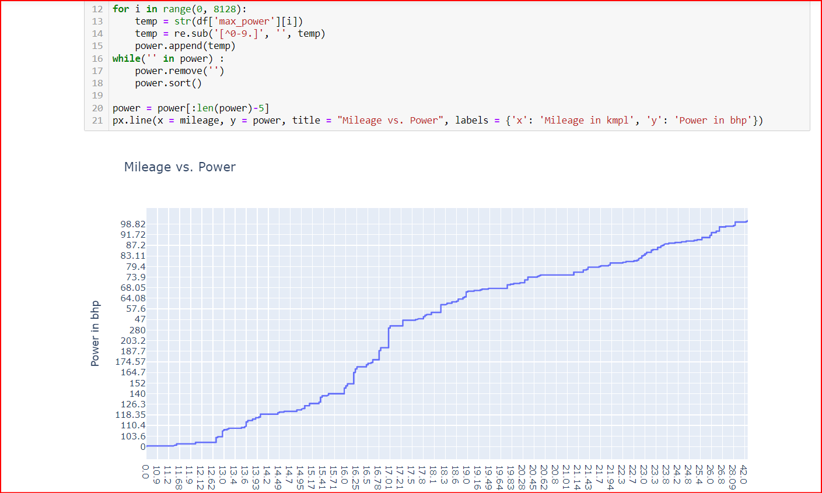

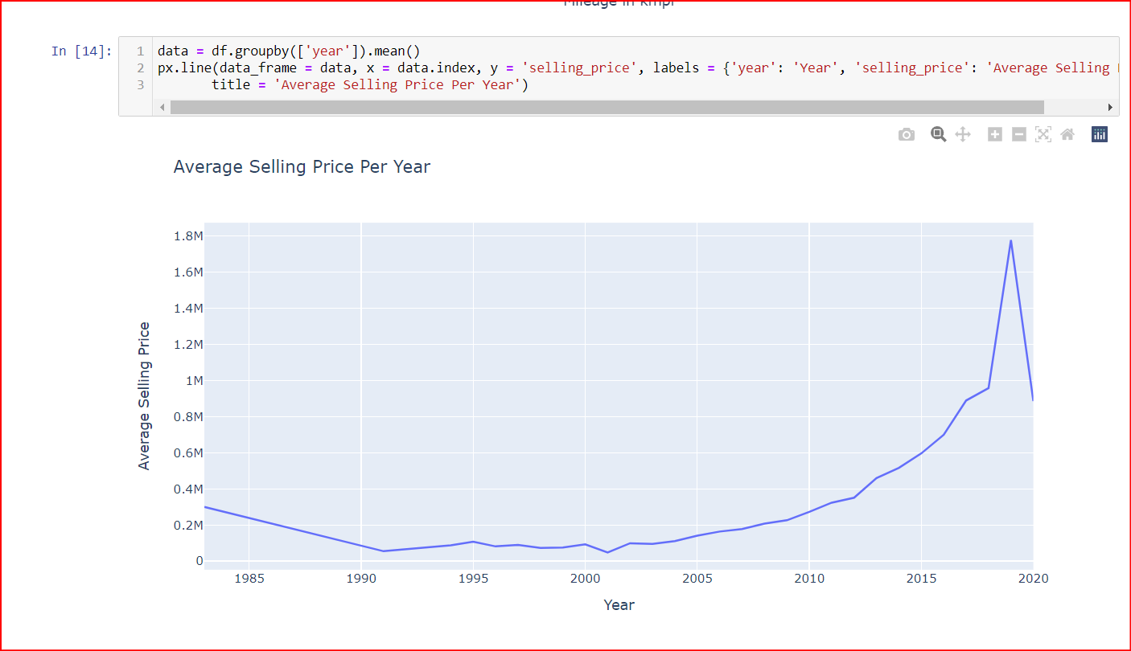

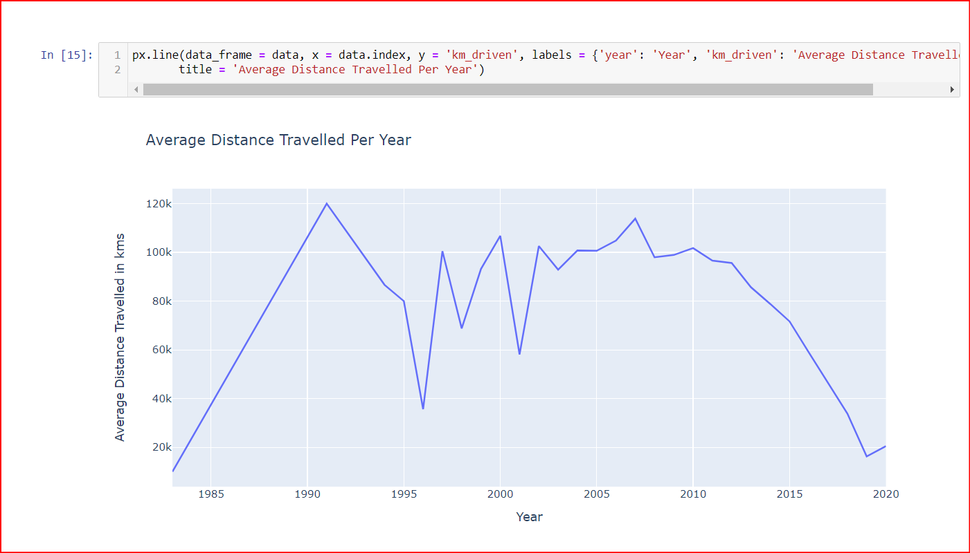

4. Psychographic Analysis

Psychographics helps in understanding consumer behaviour by analyzing their personality, values, interests, and lifestyle. It provides insights into the motivations and attitudes of the target audience, which can help marketers create more effective marketing strategies. By understanding the psychographics of their target audience, businesses can tailor their products and services to better meet customer needs and preferences.

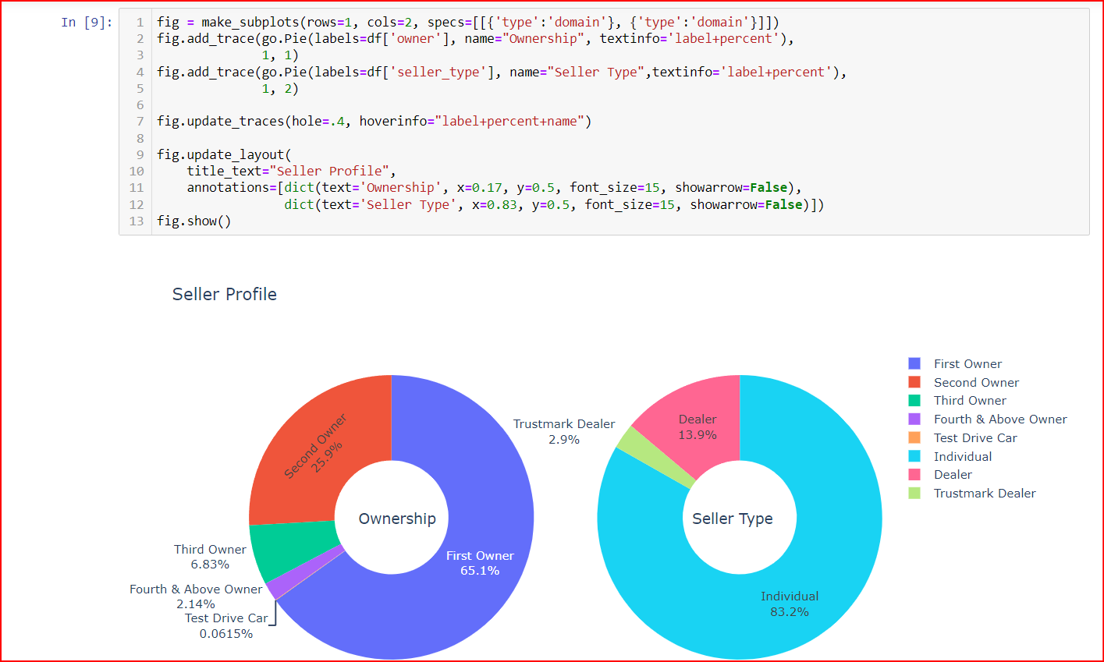

5. Demographic Analysis:

Demographic analysis helps in understanding the characteristics of a population, such as age, gender, income, and education. It provides insights into the preferences and behaviors of a particular group, which can help in developing effective marketing strategies. By understanding the demographic makeup of their target audience, businesses can tailor their products and services to better meet customer needs and preferences.

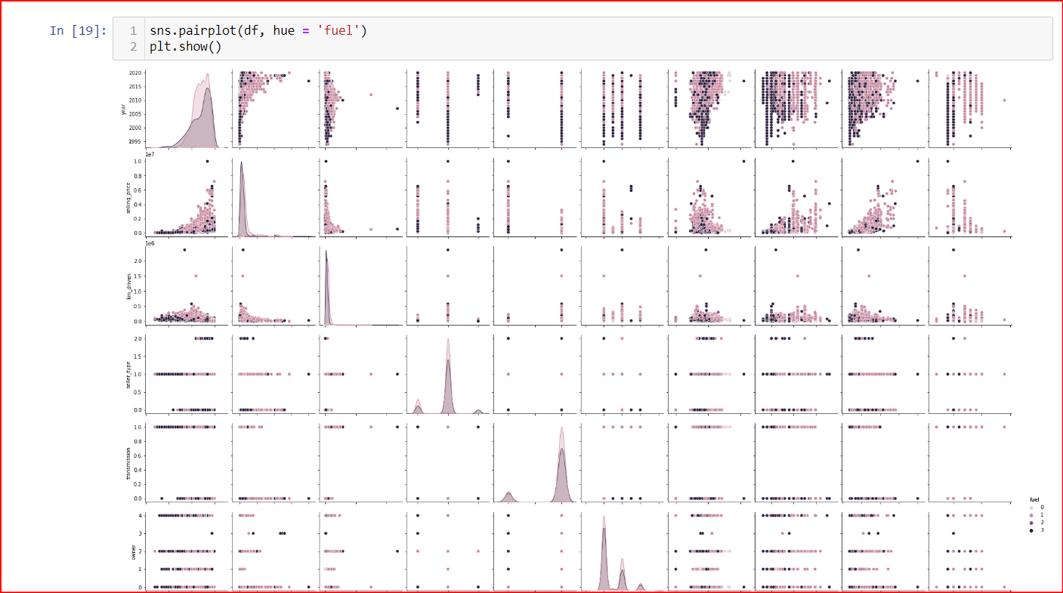

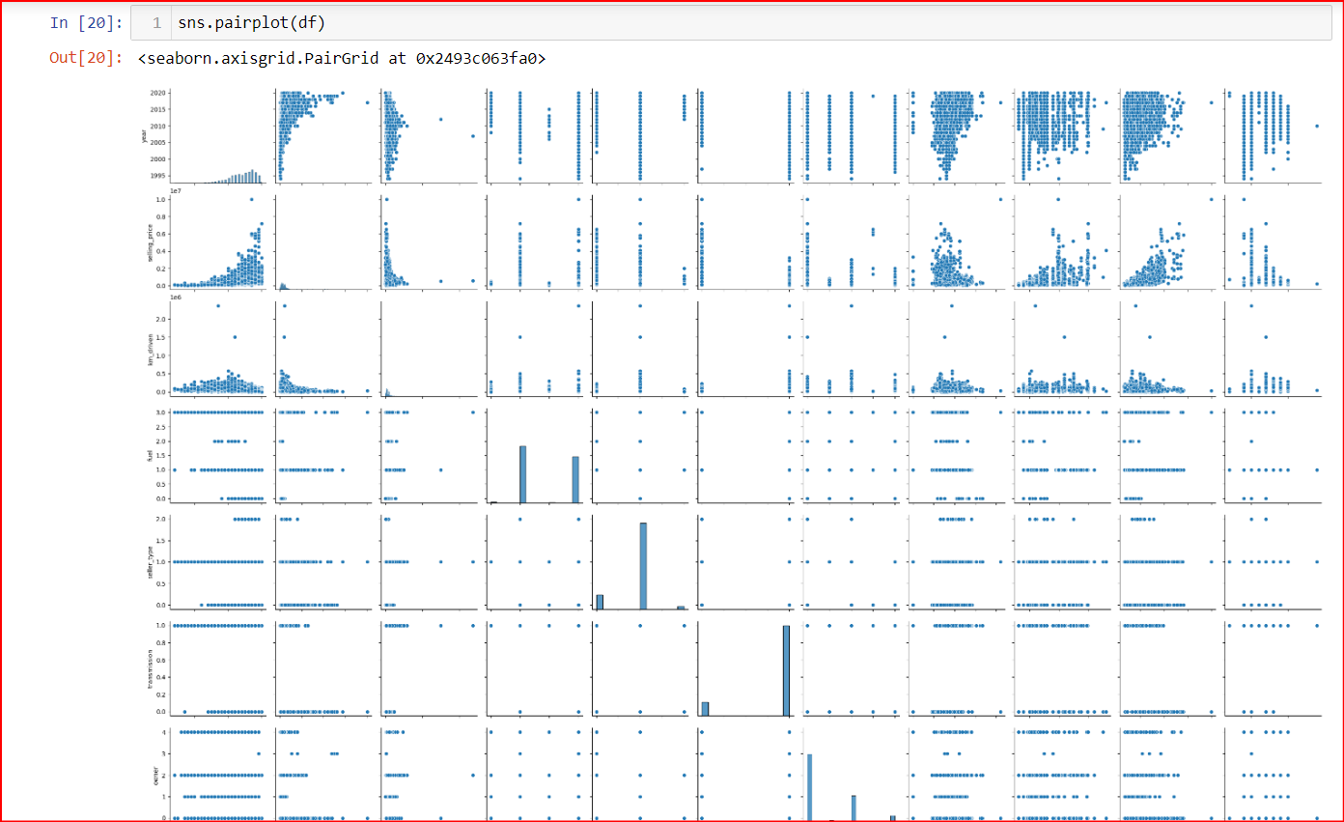

6. Behaviour Analysis:

Behaviour analysis helps in understanding the actions and choices made by individuals, providing insights into their preferences and motivations. It helps businesses identify the factors that influence consumer behaviour and develop effective marketing strategies. By understanding consumer behaviour, businesses can improve their products and services, enhance customer satisfaction, and increase profitability.

